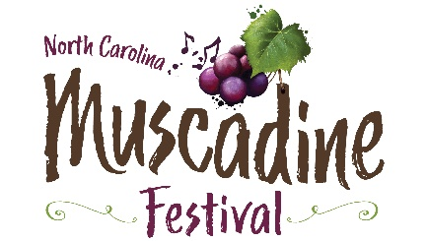

Food Vendor Application
2024 North Carolina Muscadine Festival
Saturday, September 28th, 2024
10am-6pm
Duplin County Events Center Grounds, Kenansville, North Carolina
(Vendors will not be allowed to have a moving vehicle in the festival area until after closing)

- Spaces are limited and are on a first-come basis.
- Application deadline is August 30, 2024.
- Food vendor applicants must complete temporary food vendor application from the Duplin County Health Dept. Call 910-296-2126 for details.
- NC Muscadine Harvest Festival reserves the right to approve
all vendors.

Vendor Name: _____________________________________________________
Address: __________________________________________________________
City, State, Zip: ____________________________________________________
Phone #: ______________________ Email Address: ______________________
Food Trucks – no electricity - $300 ____
Food trucks – electricity needed - $350 ____
Food Vendor (non-truck) – no electricity - $200 ___
Food Vendor (non-truck) – electricity needed - $250 ____
Additional vendor wristbands (up to two) x $10 each (2 provided) $ _____ Total enclosed $__________
Specify two main menu items: ________________________________________
List complete proposed festival menu: __________________________________
___________________________________________________________________

Please make checks payable to: NC Muscadine Festival, 195 Fairgrounds Dr, Kenansville, NC 28349. (Checks must be included with application form to be considered. If application is not accepted, check will be returned).

For questions, call, or email Christa Parker at 910-296-2181,
muscadinefestival@gmail.com

