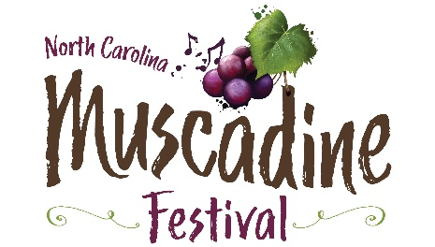

Please join us for the 20th annual
North Carolina Muscadine Festival
Saturday, September 28, 2024 – 10 a.m. – 6 p.m.
Duplin County Events Center Grounds, Kenansville, North Carolina

www.ncmuscadinefestival.com

Contact: Christa Parker 910-296-2181
email: muscadinefestival@gmail.com

TAILGATING INFORMATION & RESERVATION

Tailgate space for the 2024 NC Muscadine Festival is assigned on a first-come, first-served basis. OPTIONAL: Tailgate decoration contest information follows the reservation form. While not required, all tailgate parties are invited and encouraged to participate.

COST $250 before August 30, 2024
$300 after August 30, 2024

WHAT YOU GET (UPON ARRIVAL AT CHECK-IN):
- 10’ X 10’ area – marked with your name
- Four festival wristbands (to receive a commemorative glass, please use the wristband to enter the festival at the front gate).
- One parking pass
- One bottle of wine
- Extra tickets can be purchased through the Duplin County Events Center ticket booth on the day of the event or Etix. See the ticket tab on our website.

WHAT YOU CAN BRING:
- Tent / Chairs / Table / Grill
- Coolers for food (to be kept within the confines of your area – Please do not distribute food to individuals outside of your group as it may negatively impact sales for our food vendors.
- NO OUTSIDE ALCOHOLIC BEVERAGES OF ANY KIND ALLOWED (Please note: Coolers and other containers will be subject to security inspection at check-in.)

SET UP TIMES:
Friday, September 27: 9 a.m. – 4 p.m.
Saturday, September 28: 7 a.m. – 9:00 a.m.

You will be allowed to drive your vehicle (ONLY during the times listed above) to your spot to unload your belongings. Please follow the one-way driving pattern. You will be allowed 15 minutes to unload your vehicle before being required to move it to allow for space for other vehicles. All vehicles must be out of the festival area by 9:00 a.m. on the day of the festival.

Please note:
- The NC Muscadine Festival reserves the right to assign tailgate space on a first-come, first-served basis.
- Failure to follow the guidelines set forth by the NCMF will result in expulsion from the festival. (NO refund given.)
- A $50 fee will be assessed for any refund requests.

Please do not hesitate to give us a call or send an email if you have questions.
Thank you!

****The Duplin Events Center staff sprays for fire ants and mosquitos prior to the festival, but this does not guarantee that the area will be free of these pests. You are encouraged to bring ground cover and spray for your own protection. As a health and safety precaution, spraying will not be allowed during the festival.

2024 NC Muscadine Festival Tailgating Reservation

Payment can be made by check, made payable to NC Muscadine Festival. The completed reservation form should be mailed with a check to NC Muscadine Festival / 195 Fairgrounds Drive, Kenansville, NC 28349

Number of spaces x $250 (by August 30, 2024)
Number of spaces x $300 (after August 30, 2024)

Enclosed is a check for $ ____________ ________________________________

Name:

Address

City Zip

Phone:

Email:

I plan to participate in the Tailgate Decorating Contest: Yes __ No ___
(See information below)

Thank you!

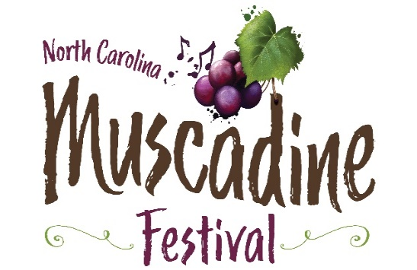

2024 NC Muscadine Festival Tailgate Decorating Contest

Help us add a fun and festive look to the festival by decorating your tailgate space!

Let your imagination go wild!!!

Prizes:
Tailgaters who wish to participate will be judged on creativity, originality, wine/grape theme, and/or humor.

First Place: Free tailgate space at the 2025 festival
Two Festival T-shirts
One bottle of NC wine
Second Place: Two T-shirts
One bottle of NC wine.
Third Place: One bottle of NC wine

Rules:

- No “indecent” themes or items. Remember, we have children present!!!
- NC Muscadine Festival reserves the right to remove any decorations that the festival deems offensive.

Judging:

- Judging will take place between 2 – 3 p.m. on Saturday.
- Winners will be announced, and prizes will be awarded directly after judging.
- You will not know who the judges are, so no bribing!

